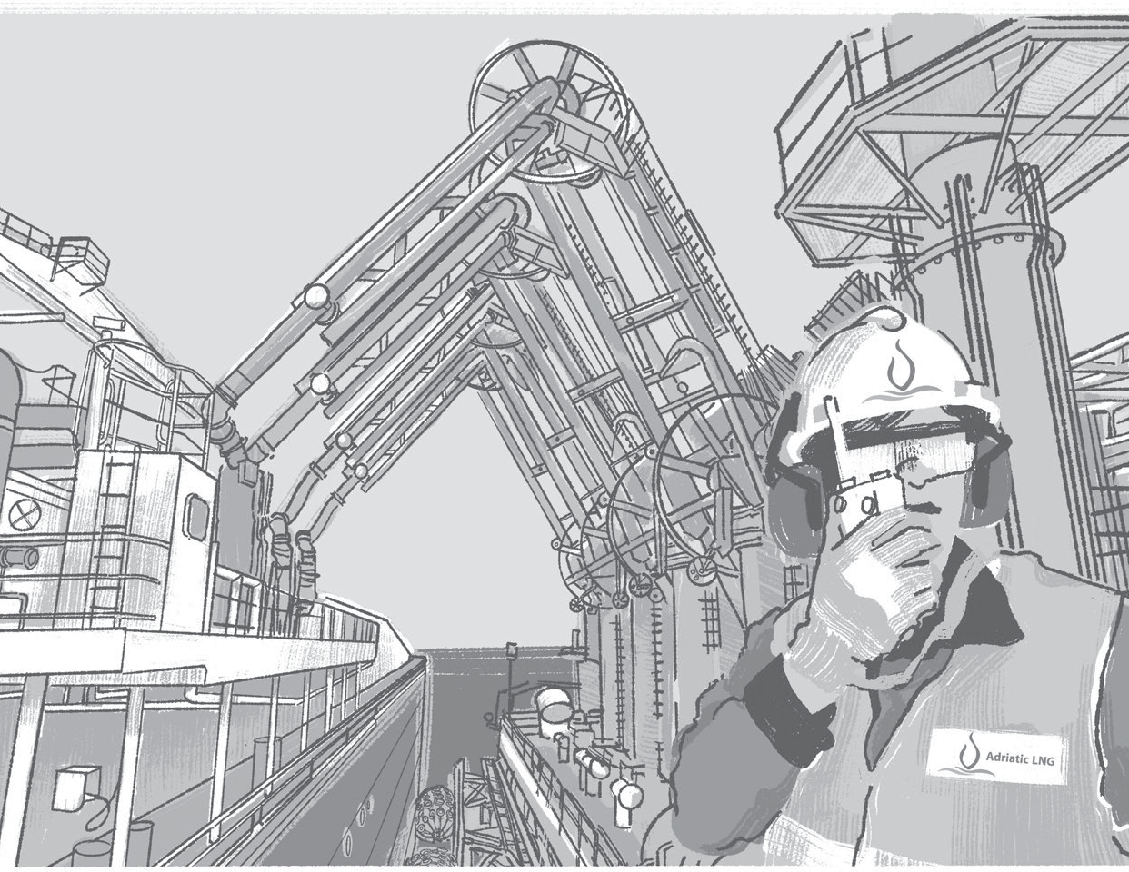
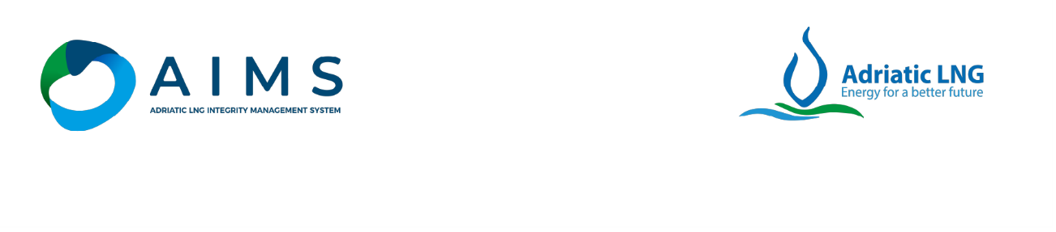
Terminal Regulations & Information Booklet
Terminale GNL Adriatico S.r.l.

REVisions
N. Rev. | Description of Revisions
0 | - According to new AIMS System this is the first issue of the document.  With reference to previous System this shall be intended as rev. n.7

RELATED DOCUMENTATION

Attachment 1 - Fender Specification
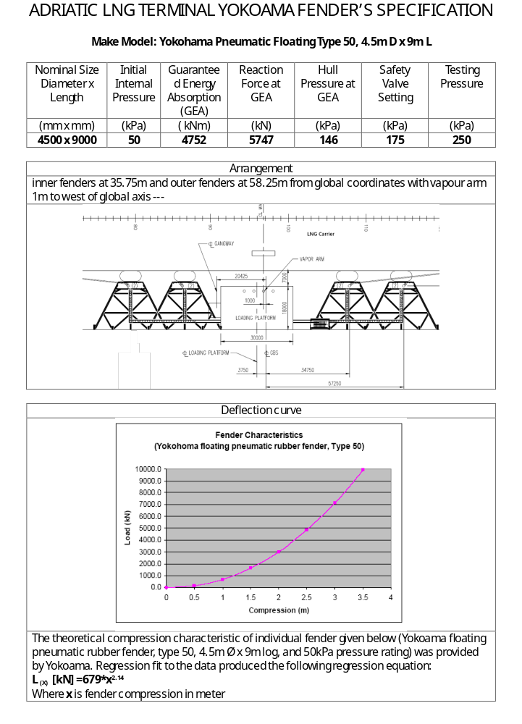

Attachment 2 - Emergency Response Actions
The response to any incident will depend on the nature, location and seventy of the event.
ALNG and LNG Carrier must be directed by their respective Emergency Response Flans
The following contains bulleted immediate actions are to be taken by the principle parties.

If marine craft (s) are required to approach or go to alongside the LNG Carrier concerned, they must only do so after ALNG has confirmed that unloading operations have been stopped.
The following list of minimum actions of Masters Is provided without prejudice to Che actions the Master shall undertake in addition as a prudent and diligent operator.

All Incidents

LNG Carrier Related Incidents
ACTIONS BY LNG Carrier
- Initiate emergency cargo transfer shutdown and closure of ESD valves
- Raise General Alarm and Initiate Emergency Response plan as required
- Inform ALNG and keep informed, of the nature and location of incident (e.g., Mooting Failure/LNG Carrier out of position/Fire) and action being taken by LNG Carrier and assistance required ALNG and Maritime Authorities
- Inform onboard Terminal Representative and Pilot
- Notify Tugs to be on stand-by and ready to provide assistance as required
- Prepare for loading arm disconnection and unmooring, including emergency unmooring
ACTION BY ALNG
- Initiate emergency shut-down of cargo transfer
- Initiate Terminal Emergency Response Plan
- Establish communications with stand-by tugs
- Establish communications with onboard Terminal Representative
- Advise Maritime Authorities, of the nature of incident and to stand by in case assistance is required
ACTION BY TUGS & PILOT
- Go to immediate stand-by
- Tugs Initiate water spray or deluge systems as required
- Await Instructions as directed by ALNG or LNG Carrier Master

Terminal Related Incidents
ACTION BY ALNG
- Raise General Alarm and initiate Terminal Emergency Response Plan
- Initiate emergency LNG transfer shut-down and closure of ESD valves
- Inform the LNG Carrier of the nature of the incident and keep them informed of status
- Advise Maritime Authorities of the nature of the incident and to stand-by in case assistance is required
- Request all tugs to go to standby
- Establish communications with onboard Terminal Representative and to standby as directed
ACTION BY LNG Carrier
- Action required by LNG Carrier's berthed alongside the Terminal's jetty will depend on the nature, location and proximity of the Incident to the jetty
- Initiate cargo shutdown
- Initiate onboard emergency response plan
- Standby for loading arm disconnection and unmooring, including emergency unmooring
- Maintain radio contact with Terminal
- Notify Terminal Representative and Pilot
ACTION BY TUGS & PILOT
- Go to immediate stand-by
- Tugs Initiate water spray or deluge systems as required
- Await Instructions as directed by Terminal or LNG Carrier Master

Specific Incidents
The following contains specific additional bulleted immediate actions to be taken by the parties
Oil spill from LNG Carrier
ACTION BY LNG Carrier
- Isolate source of pollution and take whatever steps necessary to prevent or minimise
- Mobilize onboard pollution response plan
- Initiate clean up onboard
ACTION BY ALNG
- Verify source and type of pollutant
- Secure all sources of ignition

ACTION BY TUGS
- Stand-by tugs prepare to assist.
- Stand off upwind until nature and type of spill has been established.
Uncontrolled release of LNG Vapor or Liquid from Ship / Shore
ACTION BY LNG Carrier
- Secure all sources of ignition and impose a total smoking ban
- Initiate water spray systems or deluge as required
ACTION BY ALNG
- Secure all sources of ignition and impose a total smoking ban
- Allow automatic Fire and Gas, fire extinguishing and emergency shutdown and depressurization systems to work
- Operate Jetty fire monitors if applicable
ACTION BY TUGS & PILOT
- Stand-by tugs to activate fire fighting and deluge systems.
- Stand well clear upwind.
- Await instructions from Terminal,
- Secure all ignition sources,
- Impose total smoking ban.
LNG Carrier Collision within Safety Zone
ACTION BY LNG CARRIER(S)
- Identify other vessel and render assistance as required
ACTION BY ALNG
- Initiate call out of Terminal Man-overboard response team
- Place medical services on standby
ACTION BY TUGS
- Stand-by tugs to respond as directed by Terminal or LNG Carrier Master
Man overboard Incident within the Terminal
In the event of a man overboard situation within the Terminal Safety Zone, ail LNG Carrier movements are to be suspended while search and rescue activities take piece.
Extreme caution is required by the search vessels, particularly during hours of darkness, when approaching or entering the search area

ACTION BY LNG CARRIER
- Throw person In the water a life buoy or floating aid
- Raise the alarm by sounding three long blasts on the LNG Carrier's whistle
- Inform Terminal Central Control Room who will stop the unloading if the person In the water is within 100m of the Terminal and advice circumstances
- Place lookout and constantly monitor position of person in the water
- Request Terminal Central Control Room to mobilize rescue from the Maritime Authorities
- Direct responding vessels to the person in water
ACTION BY ALNG
- Stop unloading if requested or if person in water is within 100m of the Terminal
- Inform Maritime Authorities
- Initiate call out of Terminal Man-overboard response team
- Place medical services on standby
ACTION BY TUGS
- Stand-by tugs to respond as directed by Terminal or LNG Carrier Master,
- Remaining tugs to be mobilized, if required

LNGC Out of Position
ACTION BY LNG Carrier
- Initiate emergency shut-down procedures,
- Clear manifold area in ease of ES2 activation
- Prepare to for tug connection and unmooring, Including emergency unmooring
ACTION BY ALNG
- Initiate or confirm emergency shut-down
- Prepare for Loading arm disconnection and raising of gangway
- Consider Initiating Jetty area fire and deluge systems
- Prepare for release of LNGC, including emergency release
ACTION BY TUGS & PILOT
- Proceed to LNGC and prepare for connecting towlines
- Await Instructions from Pilot or LNGC master for unberthing operations

Attachment 3 - Manifold Specification
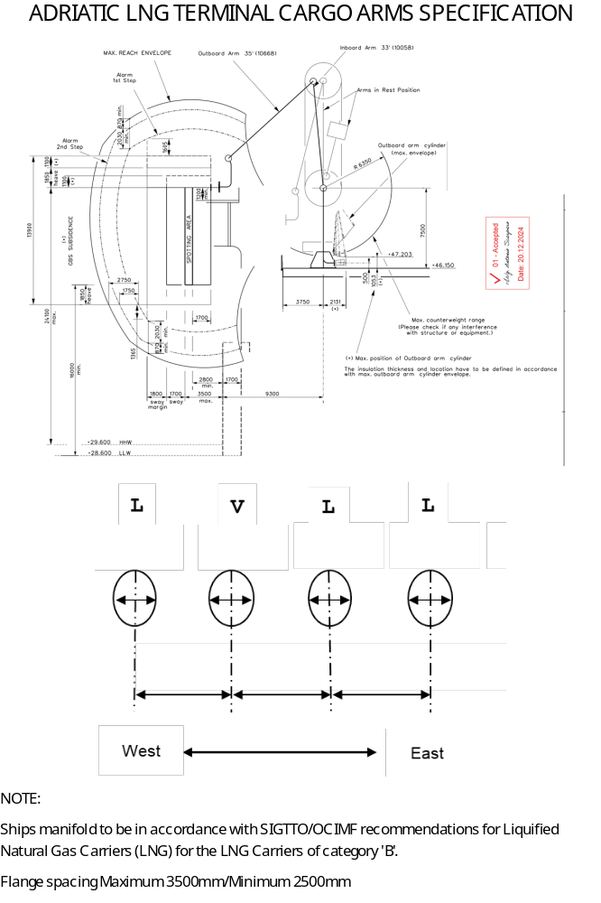

Attachment 4 - Pretransfer meeting
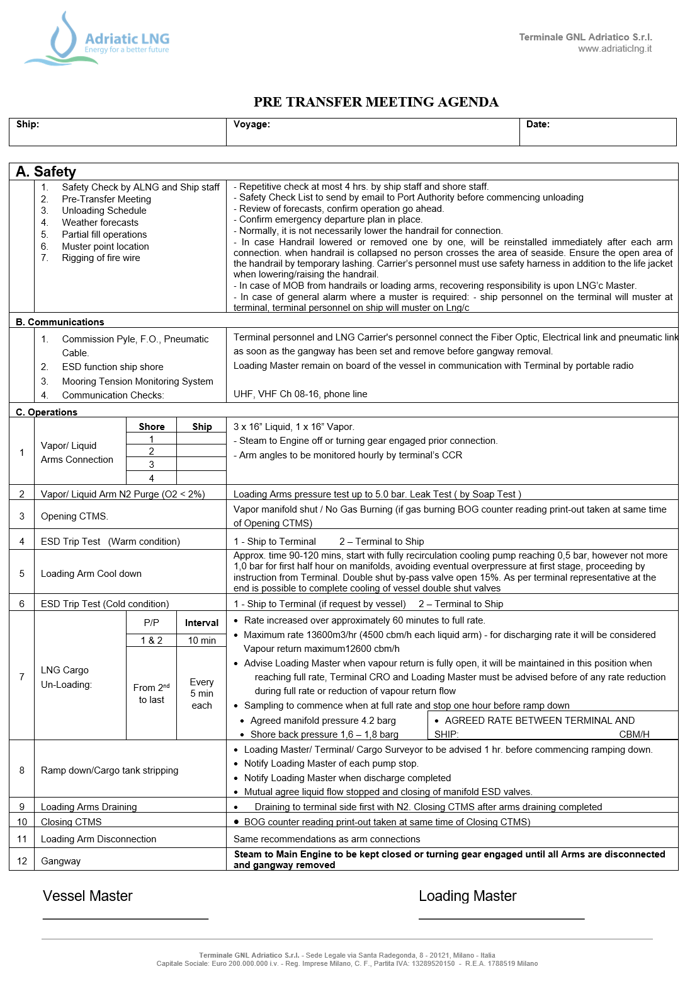

Attachment 5 - Ship Shore Safety Check List and repetitive checks

SGOTT Checks pre-arrival Ship/Shore Safety Checklist (Sixth edition)
Date and time:
Port and berth: | ADRIATIC LNG - Porto Levante (Rovigo-Italy)
Tanker:
Terminal: | ADRIATIC LNG
Product to be transferred: | LNG

Part 1A. Tanker: checks pre-arrival
Item | Check | Status | Remarks
1 | Pre-arrival information is exchanged (6.5, 21.2) | Yes
2 | International shore fire connection is available (5.5, 19.4.3.1) | Yes
3 | Transfer hoses are of suitable construction (18.2) | Yes
4 | Terminal information booklet reviewed (15.2.2) | Yes
5 | Pre-berthing information is exchanged (21.3, 22.3) | Yes
6 | Pressure/vacuum valves and/or high velocity vents are operational (11.1.8) | Yes
7 | Fixed and portable oxygen analysers are operational (2.4) | Yes
Part 1B. Ship checks pre-arrival if using an inert gas system: N/A FOR LNG VESSEL
Part 2. Terminal: checks pre-arrival
12 | Pre-arrival information is exchanged (6.5, 21.2) | Yes
13 | International shore fire connection is available (5.5, 19.4.3.1, 19.4.3.5) | Yes
14 | Transfer equipment is of suitable construction (18.1, 18.2) | Yes
15 | Terminal information booklet transmitted to tanker (15.2.2) | Yes
16 | Pre-berthing information is exchanged (21.3, 22.3) | Yes

ISGOTT Checks after mooring Ship/Shore Safety Checklist
Part 3. Tanker: checks after mooring
17 | Fendering is effective (22.4.1) | Yes
18 | Mooring arrangement is effective (22.2, 22.4.3) | Yes | AS PER MOORING PLAN
19 | Access to and from the tanker is safe (16.4) | Yes
20 | Scuppers and savealls are plugged (23.7.4, 23.7.5) | Yes
21 | Cargo system sea connections and overboard discharges are secured (23.7.3) | Yes
22 | Very high frequency and ultra high frequency transceivers are set to low power mode (4.11.6, 4.13.2.2) | Yes
23 | External openings in superstructures are controlled (23.1) | Yes
24 | Pumproom ventilation is effective (10.12.2) | Yes
25 | Medium frequency/high frequency radio antennae are isolated (4.11.4, 4.13.2.1) | Yes
26 | Accommodation spaces are at positive pressure (23.2) | Yes
27 | Fire control plans are readily available (9.11.2.5) | Yes
Part 4. Terminal: checks after mooring
28 | Fendering is effective (22.4.1) | Yes
29 | Tanker is moored according to the terminal mooring plan (22.2, 22.4.3) | Yes | AS PER MOORING PLAN
30 | Access to and from the terminal is safe (16.4) | Yes | TERMINAL GANGWAY
31 | Spill containment and sumps are secure (18.4.2, 18.4.3, 23.7.4, 23.7.5) | Yes

ISGOTT Checks pre-transfer Ship/Shore Safety Checklist
Date and time:
Port and berth: | ADRIATIC LNG - Porto Levante (Rovigo-Italy)
Tanker:
Terminal: | ADRIATIC
Product to be transferred: | LNG

Part 5A. Tanker and terminal: pre-transfer conference
Item | Check | Tanker status | Terminal status | Remarks
32 | Tanker is ready to move at agreed notice period (9.11, 21.7.1.1, 22.5.4) | Yes | Yes
33 | Effective tanker and terminal communications are established (21.1.1, 21.1.2) | Yes | Yes | Form 11.5 terminal
34 | Transfer equipment is in safe condition (isolated, drained and de-pressurised) (18.4.1) | Yes | Yes
35 | Operation supervision and watchkeeping is adequate (7.9, 23.11) | Yes | Yes
36 | There are sufficient personnel to deal with an emergency (9.11.2.2, 23.11) | Yes | Yes | ERT(Emer.Resp.Team)
37 | Smoking restrictions and designated smoking areas are established (4.10, 23.10) | Yes | Yes | WARNING POSTED
38 | Naked light restrictions are established (4.10.1) | Yes | Yes | WARNING POSTED
39 | Control of electrical and electronic devices is agreed (4.11, 4.12) | Yes | Yes | “Ex” type
40 | Means of emergency escape from both tanker and terminal are established (20.5) | Yes | Yes
41 | Firefighting equipment is ready for use (5, 19.4, 23.8) | Yes | Yes
42 | Oil spill clean-up material is available (20.4) | Yes | Yes
43 | Manifolds are properly connected (23.6.1) | Yes | Yes
44 | Sampling and gauging protocols are agreed (23.5.3.2, 23.7.7.5) | Yes | Yes
45 | Procedures for cargo, bunkers and ballast handling operations are agreed (21.4, 21.5, 21.6) | Yes | Yes | At meeting
46 | Cargo transfer management controls are agreed (12.1) | Yes | Yes | At meeting
48 | Cargo tank gas freeing arrangements agreed (12.4) | Yes | Yes | See also part 7C N/A
49 | Cargo and bunker slop handling requirements agreed (12.1, 21.2, 21.4) | Yes | Yes | See also part 7C N/A
50 | Routine for regular checks on cargo transferred are agreed (23.7.2) | Yes | Yes
51 | Emergency signals and shutdown procedures are agreed (12.1.6.3, 18.5, 21.1.2) | Yes | Yes | Form 11.6 terminal
52 | Safety data sheets are available (1.4.4, 20.1, 21.4) | Yes | Yes | In CCR
53 | Hazardous properties of the products to be transferred are discussed (1.2, 1.4) | Yes | Yes | At meeting
54 | Electrical insulation of the tanker/terminal interface is effective (12.9.5, 17.4, 18.2.14) | Yes | Yes
55 | Tank venting system and closed operation procedures are agreed (11.3.3.1, 21.4, 21.5, 23.3.3) | Yes | Yes | NO VENTING FOR LNG
56 | Vapour return line operational parameters are agreed (11.5, 18.3, 23.7.7) | Yes | Yes | FREE FLOW METOD
57 | Measures to avoid back-filling are agreed (12.1.13.7) | Yes | Yes | At meeting
58 | Status of unused cargo and bunker connections is satisfactory (23.7.1, 23.7.6) | Yes | Yes
59 | Portable very high frequency and ultra high frequency radios are intrinsically safe (4.12.4, 21.1.1) | Yes | Yes | <1 watt
60 | Procedures for receiving nitrogen from terminal to cargo tank are agreed (12.1.14.8) | Yes | Yes | At meeting

Part 5B. Tanker and terminal: bulk liquid chemicals. Checks pre-transfer N/A FOR LNG
Part 5C. Tanker and terminal: liquefied gas. Checks pre-transfer
71 | Inhibition certificate received (if required) from manufacturer | n/a | n/a | N/A
72 | Water spray system is operational (5.3.1, 19.4.3) | Yes | Yes
73 | Appropriate personal protective equipment is identified and available (4.8.1) | Yes | Yes
74 | Remote control valves are operational | Yes | Yes
75 | Cargo pumps and compressors are operational | Yes | Yes
76 | Maximum working pressures are agreed between tanker and terminal (21.4, 21.5, 21.6) | Yes | Yes
77 | Reliquefaction or boil-off control equipment is operational | Yes | Yes
78 | Gas detection equipment is appropriately set for the cargo (2.4) | Yes | Yes
79 | Cargo system gauge operation and alarm set points are confirmed (12.1.6.6.1) | Yes | Yes
80 | Emergency shutdown systems are tested and operational (18.5) | Yes | Yes
81 | Cargo handling rate and relationship with valve closure times and automatic shutdown systems is agreed (16.8, 21.4, 21.5, 21.6) | Yes | Yes | SHORE: 60 SEC  SHIP:
82 | Maximum/minimum temperatures/pressures of the cargo to be transferred are agreed (21.4, 21.5, 21.6) | Yes | Yes | MAX MANIFOLD 4.2 BAR
83 | Cargo tank relief valve settings are confirmed (12.11, 21.2, 21.4) | Yes | Yes

Part 6. Tanker and terminal: agreements pre-transfer
Part 5 item | Agreement | Details |  | Tanker initials | Terminal initials
32 | Tanker manoeuvring readiness | Notice period (maximum) for full readiness to manoeuvre:  Period of disablement (if permitted):
33 | Security protocols | Security level: 1 2 3  Local requirements:
33 | Effective tanker/terminal communications | Primary system: OPTIC/EL LINK  Backup system:LM radio, in Em.cy VHF 08
35 | Operational supervision and watchkeeping | Tanker: 1 OFF, 3 RATING  Terminal: 2 CRO, 2 MULTI-CRAFT
37  38 | Dedicated smoking areas and naked lights restrictions | Tanker:  Terminal: dedicated terminal smoking area.
45 | Maximum wind, current and sea/swell criteria or other environmental factors | Stop cargo transfer:  Disconnect:  Unberth:
45  46 | Limits for cargo, bunkers and ballast handling | Maximum transfer rates: 13600 CBM/H  Topping-off rates:  Maximum manifold pressure: 4.2 BAR  Cargo temperature: -160°C  Other limitations: terminal MARVS 250 mbar
45  46 | Pressure surge control | Minimum number of cargo tanks open:  Tank switching protocols:  Minimum number of cargo tanks open:  Tank switching protocols:  Full load rate:  Topping-off rate:  Closing time of automatic valves:
46 | Cargo transfer management procedures | Action notice periods:  Transfer stop protocols:
50 | Routine for regular checks on cargo transferred are agreed | Routine transferred quantity checks:  1 HOUR
51 | Emergency signals | Tanker:  Terminal: ATT 11.6
Part 6. Tanker and terminal: agreements pre-transfer
55 | Tank venting system | Procedure: N/A
55 | Closed operations | Requirements:
56 | Vapour return line | Operational parameters: FREE FLOW  Maximum flow rate: 12600 CBM/H
60 | Nitrogen supply from terminal | Procedures to receive:  Maximum pressure: 5 bar  Flow rate:
83 | For gas tanker only:  cargo tank relief valve settings | Tank 1:________Tank 2:_________  Tank 3:________Tank 4:_________  Tank 5:________Tank 6:_________
XX | Exceptions and additions | Special issues that both parties should be aware of:
Part 7A. General tanker: checks pre-transfer
84 | Portable drip trays are correctly positioned and empty (23.7.5) |  | Yes
85 | Individual cargo tank inert gas supply valves are secured for cargo plan (12.1.13.4) |  | Yes
86 | Inert gas system delivering inert gas with oxygen content not more than 5% (11.1.3) |  | Yes
87 | Cargo tank high level alarms are operational (12.1.6.6.1) |  | Yes
88 | All cargo, ballast and bunker tanks openings are secured (23.3) |  | Yes

Declaration
We the undersigned have checked the items in the applicable parts 1 to 7 as marked and signed below:
 | Tanker | Terminal
Part 1A. Tanker: checks pre-arrival |  | N/A
Part 2. Terminal: checks pre-arrival | N/A
Part 3. Tanker: checks after mooring |  | N/A
Part 4. Terminal: checks after mooring | N/A
Part 5A. Tanker and terminal: pre-transfer conference
Part 5C. Tanker and terminal: liquefied gas. Checks pre-transfer
Part 6. Tanker and terminal: agreements pre-transfer
Part 7A. General tanker: checks pre-transfer
In accordance with the guidance in chapter 25 of ISGOTT, we have satisfied ourselves that the entries we have made are correct to the best of our knowledge and that the tanker and terminal are in agreement to undertake the transfer operation. We have also agreed to carry out the repetitive checks noted in parts 8 and 9 of the ISGOTT SSSCL, which should occur at intervals of not more than 4 hours for the tanker and not more than 4 hours for the terminal. If, to our knowledge, the status of any item changes, we will immediately inform the other party.
Tanker | Terminal
Name | Name
Rank | Position
Signature | Signature
Date | Date
Time | Time

ISGOTT Checks during transfer Ship/Shore Safety Checklist
Part 8. Tanker: repetitive checks during and after transfer
Item ref | Check | Time | Time | Time | Time | Time | Time | Remarks
Interval time: ………..Hrs
8 | Inert gas system pressure and oxygen recording operational | Yes | Yes | Yes | Yes | Yes | Yes
9 | Inert gas system and all associated equipment are operational | Yes | Yes | Yes | Yes | Yes | Yes
11 | Cargo tank atmospheres are at positive pressure | Yes | Yes | Yes | Yes | Yes | Yes
18 | Mooring arrangement is effective | Yes | Yes | Yes | Yes | Yes | Yes
19 | Access to and from the tanker is safe | Yes | Yes | Yes | Yes | Yes | Yes
20 | Scuppers and savealls are plugged | Yes | Yes | Yes | Yes | Yes | Yes
23 | External openings in superstructures are controlled | Yes | Yes | Yes | Yes | Yes | Yes
24 | Pumproom ventilation is effective | Yes | Yes | Yes | Yes | Yes | Yes
28 | Tanker is ready to move at agreed notice period | Yes | Yes | Yes | Yes | Yes | Yes
29 | Fendering is effective | Yes | Yes | Yes | Yes | Yes | Yes
33 | Communications are effective | Yes | Yes | Yes | Yes | Yes | Yes
35 | Supervision and watchkeeping is adequate | Yes | Yes | Yes | Yes | Yes | Yes
36 | Sufficient personnel are available to deal with an emergency | Yes | Yes | Yes | Yes | Yes | Yes
37 | Smoking restrictions and designated smoking areas are complied with | Yes | Yes | Yes | Yes | Yes | Yes
38 | Naked light restrictions are complied with | Yes | Yes | Yes | Yes | Yes | Yes
39 | Control of electrical devices and equipment in hazardous zones is complied with | Yes | Yes | Yes | Yes | Yes | Yes
40 41  42 51 | Emergency response preparedness is satisfactory | Yes | Yes | Yes | Yes | Yes | Yes
54 | Electrical insulation of the tanker/terminal interface is effective | Yes | Yes | Yes | Yes | Yes | Yes
55 | Tank venting system and closed operation procedures are as agreed | Yes  N/A | Yes  N/A | Yes  N/A | Yes  N/A | Yes  N/A | Yes  N/A | NO VENTING PERMITTED
85 | Individual cargo tank inert gas valves settings are as agreed | Yes | Yes | Yes | Yes | Yes | Yes
86 | Inert gas delivery maintained at not more than 5% oxygen | Yes | Yes | Yes | Yes | Yes | Yes
87 | Cargo tank high level alarms are operational | Yes | Yes | Yes | Yes | Yes | Yes
 | Tanker initials

Part 9. Terminal: repetitive checks during and after transfer
Item ref | Check | Time | Time | Time | Time | Time | Time | Remarks
Interval time: …………….hrs
18 | Mooring arrangement is effective | Yes | Yes | Yes | Yes | Yes | Yes
19 | Access to and from the terminal is safe | Yes | Yes | Yes | Yes | Yes | Yes
29 | Fendering is effective | Yes | Yes | Yes | Yes | Yes | Yes
32 | Spill containment and sumps are secure | Yes | Yes | Yes | Yes | Yes | Yes
33 | Communications are effective | Yes | Yes | Yes | Yes | Yes | Yes
35 | Supervision and watchkeeping is adequate | Yes | Yes | Yes | Yes | Yes | Yes
36 | Sufficient personnel are available to deal with an emergency | Yes | Yes | Yes | Yes | Yes | Yes
37 | Smoking restrictions and designated smoking areas are complied with | Yes | Yes | Yes | Yes | Yes | Yes
38 | Naked light restrictions are complied with | Yes | Yes | Yes | Yes | Yes | Yes
39 | Control of electrical devices and equipment in hazardous zones is complied with | Yes | Yes | Yes | Yes | Yes | Yes
40 41  47 51 | Emergency response preparedness is satisfactory | Yes | Yes | Yes | Yes | Yes | Yes
54 | Electrical insulation of the tanker/terminal interface is effective | Yes | Yes | Yes | Yes | Yes | Yes
55 | Tank venting system and closed operation procedures are as agreed | Yes  N/A | Yes  N/A | Yes  N/A | Yes  N/A | Yes  N/A | Yes  N/A | NO VENTING PERMITTED
 | Terminal initials / Loading Master

Attachment 6 - Cargo Handling Agreement
LNG CARRIER : DATE :
QUANTITY OF CARGO ONBOARD:  QUANTITY OF CARGO TO DISCHARGE : |  |  |  | m3  m3 dens.
CONFIRM VAPOR WILL BE SENT BACK TO LNG Carrier:

NUMBER OF BERTH LIQUID ARMS TO BE USED FOR TRANSFER : 1 2 4 LIQUID 3 VAPOR

LNG’s CARGO LINES CONDITION : WARM COOLED-DOWN TO : ° C

TANKS CONDITION | TK No. 1 | TK No.2 |  |  | TK No.3 | TK No.4 | TK No.5 | TK No.6
PRESSURE (bar or Kpa)
CARGO TANK TEMPERATURE (°C)
Top & Bottom Average (Membrane)
Equator (Moss)
LEVEL
VOLUME
CONFIRM OPTICAL/ELECTRICAL E.S.D. IS OPERATIVE : |  |  | CONFIRM PNEUMATIC E.S.D IS OPERATIVE:
CONFIRM OPTICAL/ELECTRICAL E.S.D WILL BE USED AS  PRIMARY MEANS IN CASE OF EMERGENCY : |  |  | CONFIRM PNEUMATIC E.S.D WILL BE  USED IN CASE OF OPTICAL/ELECTRICAL E.S.D FAILURE:
CLOSING RATES OF SHORE E.S.D VALVES: |  |  | CLOSING RATES OF SHIP E.S.D VALVES:
STARTING TIME COOLDOWN (EST): |  |  | DURATION OF COOL-DOWN :
STARTING TIME OF DISCHARGE (EST) : |  |  | DURATION OF DISCHARGE (EST) :
CONFIRM STOP DISCHARGE ON : LNG CARRIER REQUEST TERMINAL REQUEST
LNG COOLDOWN RATE REQUD BY TERMINAL (M3/HR.) |  |  | AGREED UPON MANIFOLD BP : Bar or Kpa
MAX. DISCHARGE RATE FOR TERMINAL:(M3/HR.) |  |  | MAX. DISCHARGE RATE FOR LNG CARRIER :(M3/HR.)
MAXIMUM MANIFOLD BP :Bar or Kpa |  |  | MAXIMUM MANIFOLD BP : Bar or Kpa
TERMINAL STARTING RATE REQUIRED:(M3/HR.) |  |  | STRIPPING RATE :(M3/HR.)
NOTIFICATION TIME REQUIRED FOR SLOWING DOWN |  |  | NOTIFICATION TIME REQUIRED FOR STOPPING
EXPECTED RANGE OF VAPOR RETURN TEMPERATURE (Degree C) |  |  | MAXIMUM FLOW OF VAPOR RETURN (M3/HR)
CONFIRM ALL NECESSARY CARGO HANDLING PROCEDURES HAVE BEEN UNDERSTOOD:
FOR LNG Carrier |  |  | FOR ADRIATIC LNG TERMINAL
Name |  |  | Name
Position |  |  | Position
Signature |  |  | Signature
Time |  |  | Time

Attachment 7 - Communication agreement
LNG CARRIER: DATE:

 | A FIBER OPTIC / ELECTRICAL LINK HAS BEEN CONNECTED TO YOUR LNG CARRIER. IT WILL ENABLE THE FOLLOWING MEANS OF COMMUNICATIONS:
 | E.S.D FROM THE LNG Carrier  (emergency shut-down) |  | uni-directional. Can be activated at any time from the LNG Carrier in case of emergency. Inform Terminal as far as possible before use.
 | E.S.D FROM TERMINAL  (emergency shut-down) |  | uni-directional. Can be activated at any time from the Terminal in case of emergency. Inform LNG Carrier as far as possible before use.
 | HOT LINE |  | bi-directional. To contact directly the Terminal Control Room in case of emergency.
 | TERMINAL  INTERNAL LINE |  | bi-directional. To exchange normal information between LNG Carrier and Terminal Control Room during cargo handling operations.
 | PUBLIC LINE |  | bi-directional. Enable the LNG Carrier to use the national telephone network.
 | MOORING LINE  TENSION DATA |  | uni-directional. For the LNG Carrier to receive information on the tension of each mooring line.

 | A PNEUMATIC LINK HAS BEEN CONNECTED TO YOUR LNG Carrier. IT WILL ENABLE THE FOLLOWING MEANS OF COMMUNICATION :
 | E.S.D FROM THE LNG Carrier  (emergency shut-down) |  | uni-directional. Can be activated at any time from the LNG Carrier in case of emergency. Inform Terminal as far as possible before use.
 | E.S.D FROM TERMINAL  (emergency shut-down) |  | uni-directional. Can be activated at any time from the Terminal in case of emergency. Inform LNG Carrier as far as possible before use.

 | In the event that your LNG Carrier does not have a fixed U.H.F. radio system compatible with the Terminal, a PORTABLE U.H.F RADIO will be provided to your LNG Carrier. IT WILL ENABLE THE FOLLOWING MEANS OF COMMUNICATIONS :
 | Terminal Control Room  Jetty Personnel  Marine Terminal Representative | UHF ch. YES VHF ch. 08/16  UHF ch. YES VHF ch. NO  UHF ch. YES VHF ch. NO

FOR LNG Carrier | FOR ADRIATIC LNG TERMINAL
Name ................................................................................... | Name ...................................................................................
Position................................................................................. | Position.................................................................................
Signature.............................................................................. | Signature..............................................................................
Time……………………………………………………………………………. | Time………………………………………………………………………………

Attachment 8 - Emergency Stop Report
The Cargo Emergency Stop Report form must be completed when a cargo emergency stop is initiated. The form must in all cases be completed by the Terminal Representative and Master and as appropriate by Marine Terminal personnel or Maritime Authority personnel.
LNG Carrier name
Port of Registry
Terminal Representative name
LNG Carrier Master name
Cargo Emergency Stop initiated | Date |  |  | Time
Cargo Emergency Stop initiated by | LNG Carrier |  |  | Terminal
Person initiating Cargo Emergency Stop | Name |  |  | Name
Position
Cause (tick) | Fire |  |  | LNG Release
Cause (tick) | Weather |  |  | Injury
Cause (tick) | Equipment failure |  |  | Other (specify)
Details
Unmooring required? | Yes |  |  | No
Unmooring required? | Date | Time
Operations resumed? | Yes |  |  | No
Operations resumed? | Date | Time
Are appropriate reports completed and processed? | Yes |  |  | No
Are appropriate reports completed and processed? | Details
Are recommendations made to prevent recurrence before operations resume? | Yes |  |  | No
 | Details
Has Maritime Authority been informed and approved of resumption of operations? | Yes
Recommendations approved | OIM signature  Terminal Representative signature  Master signature
Report acknowledgment | Terminal Cargo Emergency Stop initiator signature  LNG Carrier Cargo Emergency Stop initiator signature
Date and Time

Attachment 9 - Master Letter of Acknowledgement
To the Master of the LNG Carrier Date:

Dear Sir,
It is a requirement hereof that the LNG Carrier’s Master shall sign a copy of this Letter on behalf of the LNG Carrier’ Owners. In the event this Letter is not so signed (or otherwise accepted), ALNG shall be under no obligation to perform or provide any services referred to in this Letter or elsewhere in the Terminal Regulations.
In addition, responsibility for the safe conduct of operations on board your LNG Carrier while at our Terminal rests with you as Master. Nevertheless since our personnel, property, and other shipping may also suffer serious damage in the event of an accident involving your LNG Carrier, before operations start, we wish to seek your full cooperation and understanding of, among others, the safety requirements set out in the Safety Checklist contained in this Terminal Regulations.
These safety requirements are based on safe practices widely accepted by LNG terminal and Carrier industries. We, therefore, expect you and all under your command to adhere strictly to them throughout your stay at the Terminal. For our part, our personnel will cooperate with you in the mutual interest of a safe and efficient operation.
To assure ourselves of your compliance with these Terms and Conditions and safety requirements, the Terminal Representative together with a responsible LNG Carrier officer will, before the start of operations and thereafter from time to time, carry out inspection(s) of cargo decks and accommodation spaces.
If we observe any actual or potential infringement on board your LNG Carrier of any of these safety requirements, we shall immediately bring this to the attention of you or your deputy requesting corrective action. If such action is not taken in a reasonable time, we shall adopt measures that we consider to be the most appropriate for dealing with the situation, and we shall notify you accordingly.
Should you consider in your best opinion that there’s any immediate threat to the safety of your LNG Carrier arising from any action on our part, or from equipment under our control, you are entitled to request to stop the Marine operation and/or unloading as the case may be.
In the event of any failure to comply fully with any of the safety requirements and/or provisions of the Terminal regulations by any LNG Carrier, we reserve the right to stop at any time all operations and to order the LNG Carrier off the mooring for appropriate action to be taken by the owners or charterers.
Please sign to indicate:
Your receipt of this letter and to confirm that
You have a copy of the Terminal Regulations, associated appendices, and Terms and Conditions of Use, and that

"I HAVE READ, UNDERSTOOD, THE REQUIREMENTS AND ACCEPT THE TERMS AND CONDITIONS OF USE AS SET OUT IN THE TERMINAL REGULATIONS AND INFORMATION MANUAL, AND ON BEHALF OF THE LNG CARRIER OWNER or CHARTERER AGREE TO BE BOUND BY THEM."

Signed for and on behalf of Terminale GNL Adriatico S.r.L.

Signed for and on behalf of Master of the LNG Carrier:

I, hereby, unconditionally approves, pursuant to and for the purposes of, articles 1341 and 1342 of the Italian Civil Code, the following clauses of the Terminal regulation: Article 1 Cap. V Restricted areas and Safety Zones ; Article 10 Cap. VIII Safe Operation Requirements; LNG Carrier Domestic Matters ; Cap.II Terminal Representative ; Article 1 Cap. VII Navigation, Pilotage and Berthing; Article 1 Cap. VII Vessel Operation status and Mooring Requirements ; Article 3 Cap. IV Vessel/Terminal security interface ; Cap. III Emergency Procedures; Article 7 Cap. IV State of readiness ; Article 19 Cap. VIII Pollution prevention ; Article 3 Cap. VIII Pre-Transfer Company Policy ; Appendix 12 Conditions of Use (acceptance of LNG carrier ; Master’s responsibility ; Agency ; Marine Terminal Closure ; Removal of Wrecks ; provision of services ;Liabilities and indemnities ; Limitation of liability ; Pollution ; Governing Law and Jurisdiction ; Changes to terminal regulation; Termination ;

Signed for and on behalf of Master of the LNG Carrier:

Attachment 10 - Berthing or unberthing decision for unplanned event

BERTHING/UN-BERTHING DECISION FOR UNPLANNED EVENT (I.E. WEATHER, TERMINAL/SHIP ISSUE)
SHIP :
VOYAGE :
Key Groups | ALIGNEMENT FROM :
OIM(Terminal)
Pilot | Chioggia Pilot
Tugs | Adriatic Towage Fleet Manager (informed)
Line Handlers | Chioggia HQ (informed)
Loading Masters
Agency | (informed)
Logistic SPTD | Last Decision (following consultation of Marine Area)
LNG/C’s Master | LNG Carrier Last Decision
Note:

MASTER (vessel’s stamp)  ……………………….. | ALNG Logistic  ………………………...

Attachment 11 - Terminal Gangway
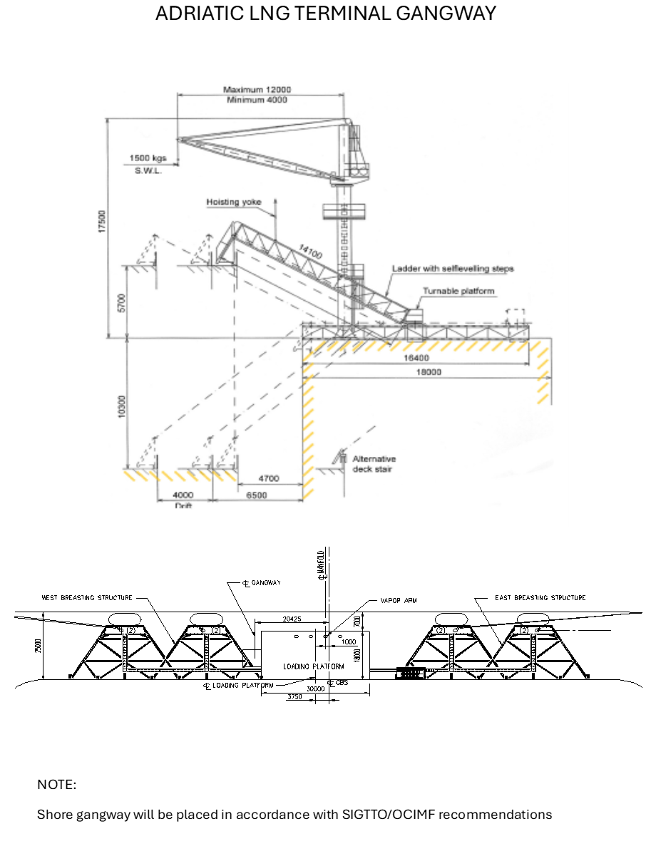

Attachment 12 - Condition of Use
1. Acceptance of LNG Carrier
All LNG Carriers calling at the Terminal are first subject to SSCS acceptance by ALNG and must satisfy among others:
- Marine Operations Manual (LNGC Vetting and Acceptance)
- Berth compatibility requirements
- Terminal Insurance liability requirements
Combinations of weather and current conditions, size, trim, and handling qualities can also affect ALNG’s decision to allow an LNG Carrier to berth at the Terminal. Should an LNG Carrier be rejected or delayed by ALNG for any reason, ALNG will supply the Master and the Ships Agent with written reasons for the rejection or delay.
The Terminal Representative is authorized by ALNG to confirm the continued eligibility of an LNG Carrier to remain at the Terminal.
ALNG reserves the right at all times to direct an LNG Carrier to leave the Terminal if the Terminal Representative or OIM determines, at his discretion that the presence of the LNG Carrier poses any threat to the Terminal, to safety, or to the environment. In such cases the Master will be consulted.

2. Master’s Responsibility
Masters of LNG Carriers calling at the Terminal are solely responsible on behalf of the owners or charterers for the safe navigation, and operation of their LNG Carriers.
Nothing contained in these Terminal Regulations relieves Masters of their responsibility from taking precautions and behave diligently to prevent among others:
- Fire;
- LNG release;
- Tank over pressurization or vacuum;
- Environmental pollution;
- Damage to the Mooring System;
- Damage to the Loading Arm System;
- Damage to the Terminal;
- Incident especially during the period that the handrail are collapsed (if lowered);
therefore, no person shall cross the seaside area and Master shall make safe the open area of the handrails by temporary lashing. In case of man overboard from handrails or loading arms, recovering responsibility is upon Master. LNG Carrier’s personnel must use safety harness in addition to the life jacket when lowering/raising the handrail
The Master remains at all times wholly and fully responsible for his or her LNG Carrier and for its officers and crew.
3. Government Officials
Italian government officials may be included in the boarding party. These may include:
- Customs Officer; and
- Immigration Officer; and
- Maritime Authority Representative.
The Ship’s Agent is responsible for advising the Master of the number of personnel expected to board and if they will be required to stay onboard throughout Unloading.

4. Agency.
The LNG Carrier Owner or Master must have arranged local agency services. The representative of the agency may board with the boarding party. ALNG and its personnel do not perform any LNG Carrier agency functions.

5. Anti-Pollution Regulation
To prevent any kind of pollution it is the responsibility of the Master to ensure that his LNG Carrier complies with all applicable Laws aimed at preventing pollution. This includes cargo, bunkers, bilge water, dirty ballast, plastics, garbage, or any other matter that results in the pollution of the sea or atmosphere. The Master must ensure that all applicable International Convention for the Prevention of Pollution from Ships (MARPOL) and Laws are complied with.
LNG Carriers must have in place a Shipboard Oil Pollution Emergency Plan (SOPEP) approved by flag State and have records to substantiate that the personnel onboard received training in responding to emergency situations.
Any fine imposed by any Government Entity for any pollution caused by the LNG Carrier or for which the LNG Carrier or its Owner are liable under any applicable law shall be for the LNG Carrier’s Owner’s account.

6. Terminal hours of operation
LNG Carriers are discharged at any hour, weather and other circumstances permitting, at the full discretion of ALNG and the Harbour Master.
Mooring and unmooring operations are conducted on a 24-hour basis, always consistent with favorable wind and sea conditions, visibility, and availability of Pilot, tugs and line handling crews.

7. Marine Terminal Closure
Any decision regarding the opening and closing of the Terminal is made solely at the sole discretion of ALNG. ALNG will provide the Master with a written notice of the times during which the Terminal is closed.
LNG Carriers required to leave the Terminal area during periods of closure and must keep in contact with the Terminal via VHF so that they are readily available when the Terminal reopens.
Closure could be caused by adverse weather conditions or any other operational reasons that prevent, or may prevent, an LNG Carrier from mooring and/or remaining safely moored.

8. Pilotage
All berthing, mooring, and unmooring operations within the Terminal areas shall be conducted with a Pilot onboard, except in emergency un-berthing situations and when the Pilot is not available for a duly motivated reason.
The Master at all times remains in command of her LNG Carrier and is fully responsible for the safety of life, the LNG Carrier, the environment, and for third-party property damages.
The Pilot remaining on the LNG Carrier during Unloading must be provided with food and accommodation of the standard usually provided for the LNG Carrier’s officers.

9. Surveyors and Government Representatives
The LNG Carrier Officer in Charge (OIC) must inform any independent cargo surveyor or Government Entity representative appointed to inspect the cargo on board that LNG Carrier of cargo information including stowage, load-port information, LNG quantities and specifications.
The OIC must ensure that surveyors and Government Entity representatives are properly accommodated and that all reasonable requests are satisfied.
If the OIC has any doubts, or if a problem or misunderstanding occurs, the OIC must inform the Terminal Representative who will endeavor to resolve any situation to the satisfaction of all concerned.

10. Drugs and Alcohol
As part of the pre-qualification screening requirements that allows the LNG Carrier to operate at the Terminal, the LNGc Company must have in force a drug and alcohol abuse policy. The drug and alcohol Company policy must be, or can be, more restrictive than the standards specified in the Oil Companies International Marine Forum Guidelines for the Control of Drugs and Alcohol Onboard Ship.
The Master must ensure that no drugs (other than those in the medical locker) are onboard and that no alcohol is used or is available for use while the LNG Carrier is present in the Terminal Safety area.
All personnel onboard the LNG Carrier located within the Terminal area must comply with the Drug and Alcohol Company Policy, a copy of which must be posted onboard in order to advertise it.
LNG Carrier personnel are reminded that while approaching and leaving the Terminal all personnel must have a zero-blood alcohol level.
11. Visitors to the Terminal or LNG Carrier
All visitors to the Terminal or LNG Carrier, including ALNG’s customers representatives, independent surveyors and Ship’s Agents will comply with the Terminal procedures and policies, including Safety, and Drug and Alcohol policies.

12. Removal of Wrecks
For removal of wreck purpose, ALNG will order the LNG Carrier in writing to remove the wreck, the LNG Carrier or part thereof that becomes an obstruction to the performance of the Terminal in any part of the Restricted areas and Safety Zones (as defined by art. 2.2 of the Terminal Regulation) or in the approaches to the Restricted areas and Safety Zones (“Wreck”). If the Wreck is not removed within 24 (twenty-four) hours from the above request, ALNG is empowered to act on behalf of the Master. In this capacity, ALNG may take any steps deemed necessary to remove the Wreck even without further notification to the Master.
All expenses for such removal will must be borne by the Owner(s) of the LNG Carrier causing the obstruction. ALNG is entitled to full reimbursement by the Owner(s) of the LNG Carrier for any reasonable expenses.

13. Provision of services
13.1 Compliance with Llaws : All services, facilities and assistance provided by or on behalf of ALNG, its parent companies, subsidiaries, or affiliates, or its or their servants, agents, or contractors, their parent companies, subsidiaries, or affiliates, or its or their servants, agents, or contractors whether or not any charge is made by ALNG therefore, are provided subject to all Laws.
13.2 ALNG’s representative on vessel : The services of the Terminal Representative are provided with the express understanding and condition that when any Terminal Representative furnished by ALNG goes on board a LNG Carrier for the purpose of assisting such LNG Carrier, he or she becomes for such purposes the servant of the Owners or Charterers of the vessel; and ALNG shall in no way be liable for any damage or personal injury including death of any nature whatsoever, incurred by any person whomsoever, in any way connected with, contributed by, or resulting from the advice or assistance given or for any action taken by such Terminal Representative, whether negligent or otherwise, while on board or in the vicinity of such assisted vessel.
13.3 LNG Carrier Navigation : except gross negligence or willful misconduct, neither ALNG its servants, co-venturers, agents, contractors in whatever capacity it may be acting shall not be in any way whatsoever responsible for or liable for any contribution with respect to any loss, damage, or delay, from whatsoever cause, or arising whether directly or indirectly in consequence of any assistance, advice, or instructions whatsoever given or tendered in respect of any vessel, whether by way of the provision of navigation facilities, including berthing aids, or otherwise howsoever. In all circumstances the Master of any LNG Carrier shall remain solely responsible on behalf of his or her owners for safety and proper navigation of his or her LNG Carrier.
14. Liabilities and indemnities
14.1 While ALNG shall exercise reasonable care to ensure that the mooring, premises, facilities, property, gear, craft, and equipment provided by ALNG are safe and suitable for vessels permitted or invited to use them, no guarantee, express or implied, of such safety and suitability is given by ALNG that such mooring, premises, facilities, property, gear, craft, and equipment are devoid of defects or are fit for the service or use to which it is put, and every vessel shall be and remain at the sole risk of the Owners and Master thereof .
14.2 ALNG, shall not be held responsible (or liable for any contribution) with respect to any loss, damage, or delays whatsoever that may be sustained by or occur to any vessel or to its Owners or its crew or cargo or for any part thereof (whether such cargo is on board or in the course of discharge) by whomsoever and by whatsoever cause such as loss, injury, damage, or delay is occasioned, unless it is caused in whole by the negligence of ALNG
14.3 If in connection with or by reason of the use by any LNG Carrier of any berth, or any other part of the Terminal or other ALNG premises, or of any gear or equipment provided by or on behalf of ALNG, or of any craft, or of any other facilities or property, of any sort whatsoever, belonging to or provided by on behalf of ALNG, any damage or injury is caused to such mooring, premises, gear or equipment, craft, or other facility or property, or any third party, or any vessel its owners and crew, from whatsoever cause such damage may arise, as a result of any negligence or fault on the part of the LNG carrier and/or its Master and/or its crew, in any such event the vessel and the LNG Carrier shall hold ALNG harmless from and indemnified against all such damage and injury and against loss sustained by ALNG consequent thereon, unless such damage has been caused in whole by the negligence of ALNG.
14.4 The LNG Carrier shall hold ALNG harmless from and indemnified against all and any action, liabilities, claims, damages, cost, awards, and expenses arising whether directly or indirectly out of any loss, damage, personal injury, including death or delay of whatsoever nature occasioned to any third party or any vessel, its Owners and crew, including the LNG Carrier and owners and crew, caused or contributed to by any negligence or fault on the part of the LNG Carrier or any part thereof or by any substance or material leaking or escaping therefrom or by any negligence or fault on the part of the Master or crew or by any other servant or agent of the Owners unless such loss, damage personal injury, including death or delay has been caused in whole by the negligence of ALNG.
14.5 Neither party shall be responsible for indirect or consequential damages, including but not limited to the loss of profit
15. Limitation of Liability
15.1 Each party shall be liable with respect to the other party for any claim under article 14, for a sum not exceeding the amount of 150.000.000,00 (one-hundred-fifty-million) USD per event. It is expressly agreed that this is the maximum liability of each party to the other party under article 14
15.2 For any claim other than those specified in paragraph 15.1, including but not limited to those under articles 12 and 18, the LNG carrier and/or their Owners and/or ALNG as the case may be, shall not be deprived of any right they may have to limit their liability in accordance with any applicable law for the time being in force.
16. Force Majeure
Meaning of Force Majeure
Force Majeure means any event or circumstance beyond the reasonable control of the Party claiming such Force Majeure, which could not be prevented by due care and reasonable expense, which has the effect of making performance by such Party of its obligations under the Terminal Regulation, in whole or in part, impossible and/or unlawful ("Force Majeure" or "Force Majeure Event").

List of Force Majeure Events
Force Majeure shall include, but not limited to the following events:
a. war (whether declared or undeclared), civil war, acts of terrorism, riot, civil disturbance, blockade, insurrection;
b. acts of God, explosion, fire, flood, atmospheric disturbance, lightning, storm, typhoon, tornado, earthquake, landslide, soil erosion, subsidence, washout ,health epidemic or health pandemic;
c. any change in a Regulation or other applicable laws, regulations, administrative or judicial provisions or such like, or coming into effect of a new regulation or other applicable laws, regulations, administrative or judicial provisions or such like, excluding any that concern tax;
d. any refusal, revocation, cancellation, or non-renewal of any authorization, permit, license and/or concession required by the Affected Party to perform its obligations under this Terminal regulation;
e. loss of, damage to, or any failure of all or part of the ALNG or of the Grid;
f. strikes including any national strike (sciopero generale), gas or energy sector strike (sciopero di categoria), or company strike (sciopero aziendale); and
g. any condition or situation which presents an imminent threat of loss or damage to any property, or of danger to the life or health of any person.

Relief for Force Majeure
Should a Force Majeure Event occur, the Party affected by such Force Majeure Event (the "Affected Party") shall be relieved of its obligations under the Terminal regulation for as long as and to the extent that the performance of its obligations is rendered impossible and/or unlawful by such Force Majeure Event, and the other Party shall be relieved of its corresponding obligations under Terminal regulation to the same extent.

Action to be taken on Force Majeure
Should any Force Majeure Event occur, the Affected Party shall:
a. promptly give notice to the other Party, by stating (i) the date, hour and place where the claimed Force Majeure Event has occurred (ii) a detailed description of the claimed Force Majeure Event (iii) the effects of the claimed Force Majeure Event; and (iv) the program that the Affected Party intends to implement to remedy the Force Majeure Event and resume normal performance of its obligations under the Terminal Regulation; and
b. in addition to paragraphs (i) through (iv) above, where the Affected Party is ALNG: (aa) the estimated period during which performance of the service will be suspended or reduced due to the Force Majeure Event and (bb) the service that the ALNG reasonably expects will not be performed or will only be partially performed during the period for which the Force Majeure Event and its effects are estimated to last; and
c. upon the expiry of each consecutive thirty (30) Day period following service of the notice pursuant to paragraph (a) above, update the information described in paragraph (a) above by notifying the other Party the following: (i) the developments in the situation; (ii) the actions being taken to remedy the Force Majeure Event and its effects; and (iii) the date on which it is reasonably expected that such Force Majeure Event and its effects will end;
d. use all reasonable endeavours (including the incurrence of reasonable expenditure) to overcome the Force Majeure Event and minimize where possible its effects on the performance of such Affected Party's obligations;
e. allow or procure the other Party, its employees, contractors, agents and/or other third party representatives (each acting for or on behalf of such other Party and with its specific approval), upon giving reasonable prior notice and at such other Party's sole risk and expense, to have access to the Terminal and/or any other place where the Force Majeure Event has occurred (to the extent that it is within the reasonable control of the Affected Party to do so), in order to check and assess the duration and effects of the Force Majeure Event, provided that such access would not present a danger to the life or health of any person; and
f. promptly give written notice to the other Party when the Affected Party is again able to perform its obligations under the relevant Capacity Agreements and shall thereupon promptly resume performance of its obligations thereunder.

17. Changes to the Terminal Regulation
ALNG may change the terms of these Terminal Regulations by giving the LNG carrier Owner at least three months’ written notice by registered letter or e-mail. Such change applies as of the date ALNG provides for in the notice. It is understood and agreed that the LNG carrier Owner consents to any such change if he does not notify ALNG in writing, at the latest 15 (fifteen) days prior to the effective date provided for in ALNG’s written notice, that he disagrees with the change. If the owner of LNG Carrier disagrees with the change ALNG has the option to withdraw from the Terminal regulation with a 15 (fifteen) without any penalty or liability to the owner LNG Carrier or any third party. In this last case the LNG Carrier has no more access to the Terminal and/or the Restricted areas and Safety Zones.

18. Pollution
LNG Carriers shall be member of the International Tanker Owners Pollution Federation Limited (ITOPF) and declares he knows its guidelines. For any oil pollution caused by the LNG Carrier, its Master, or crew, the LNG Carrier and its Owners shall protect, defend, indemnify, and hold harmless ALNG from and against any loss, damage, liability, suit, claim, or expense arising therefrom.

19. Parties and related parties
It is hereby expressly agreed that no servant or agent of ALNG shall be under any liability whatsoever for any loss, damage, or delay of whatsoever kind arising or resulting directly or indirectly from any act of neglect or default on its part while acting in the course of or in connection with its employment, and without prejudice to the generality of the foregoing provisions in this clause, every exemption, limitation, condition, and liberty herein contained and every right, exemption from liability, defense, and immunity of whatsoever nature applicable to ALNG or to which ALNG is entitled hereunder shall also be available and shall extend to protect every such servant or agent of ALNG acting as aforesaid, and for the purpose of all the foregoing provisions of this clause ALNG is or shall be deemed to be acting as agent or trustee on behalf of and for the benefit of all persons who are or might be its servants or agents from time to time, and all such persons shall to this extent be or be deemed to be parties to this agreement.

20. Governing Law and Jurisdiction
The Terminal regulations, including these conditions of use, are governed by Italian law and any dispute arising out or in connection with the Terminal Regulations will be exclusively referred to the court of Milan.

21. Termination
21.1 Notice
Each Party shall have the right at any time to give to the other Party notice of termination of this agreement on Terminal Regulation through registered letter or registered email. Such notice shall be sent with at least 30 (thirty) days notice and is effective upon receipt.
21.2 Effect of Termination
From the termination the LNG Carrier has no right to access the Safety Area and/or the Terminal. Termination of this agreement on Terminal Regulations, howsoever caused, shall be without prejudice to any rights or remedies that may have accrued prior to the time of such termination, and any provisions of this agreement necessary for the exercise of any such accrued rights or remedies shall survive expiry or termination of this agreement for such period as so required.
22. Waiver of Immunity
Each Party acknowledges and agrees that this agreement constitute a transaction and that it is not entitled to plead sovereign immunity for any purpose whatsoever, including any right to plead sovereign immunity in respect

